The connection set op is shown in Figure 1.

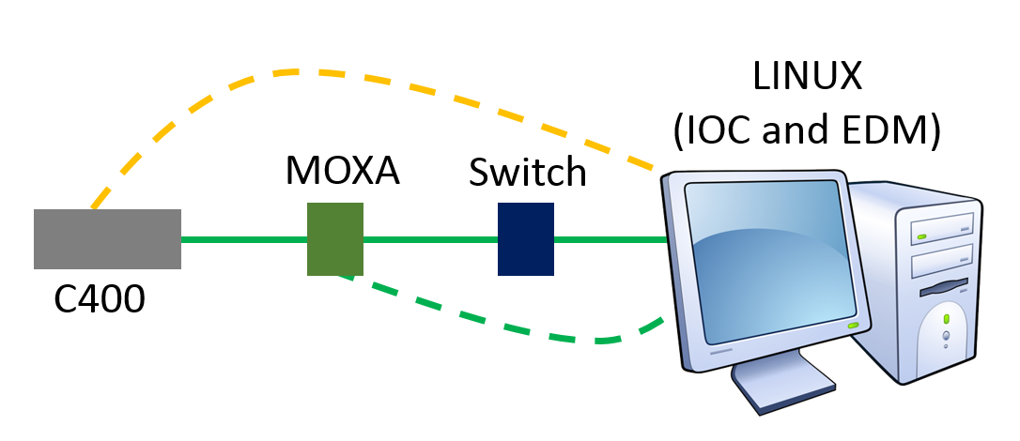

1. Connection setup. The orange dotted line shows a direct RS232 connection between the LINUX computer and the C400. It is suggested to refrain from doing a direct RS232 connection.

The described file locations are on Paw’s personal LINUX (Ubuntu 14.04 LTS 64-bit) – it’s a 17 inch black hp.

The C400 Address could be 0 and the Mode must be 3.

Ensure that the MOXA can be pinged. The MOXA settings should be like Figure 2.

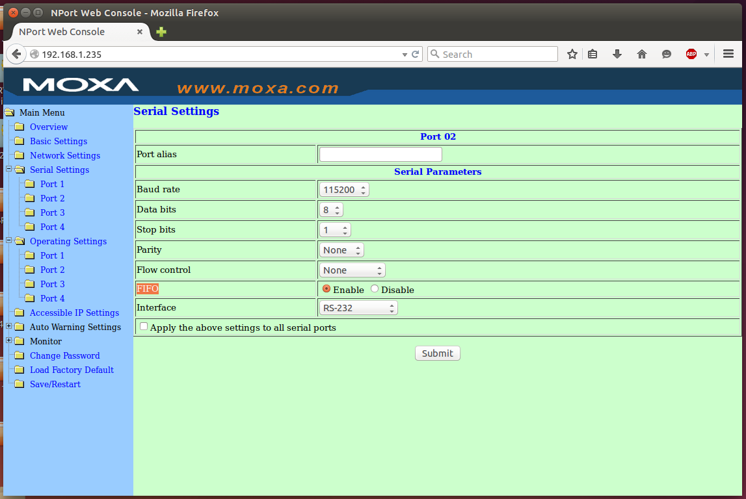

1. MOXA setting

The IOC is initiated by ./st.cmd in a terminal when in the Desktop/I404IOC/iocBoot/iocI404IOC folder.

To do this: open a terminal from the left of the screen. **All commands are case sensitive**.

To open the folder in the terminal environment you must change the directory by first typing **cd** followed by the location of the folder, then pressing enter:

cd Desktop/I404IOC/iocBoot/iocI404IOC

The command **ls** will show you the files in your current directory. This allows you to see what folders are available. To save time inputting text, you only need to type the start of the folder name enough to identify, then tab can be pressed to complete the name. For example typing De, then tab, will input ‘Desktop’. Since there is more than one folder which starts with ‘IOC’, you will need to type more.

After the directory is changed, type the command:

./st.cmd

Followed by enter.

To start the EDM you need to open a new terminal by right clicking on the terminal icon on the left of the screen and selecting a new terminal.

You need to open the folder opi_C400 as before by typing:

cd Desktop/I404IOC/opi_C400

Then enter the command:

./start_opi.sh

This will open the screen shown in figure 5.

If this does not work then ensure that the st.cmd looks like Figure 3 and the C400.substitutions looks like Figure 4. The location of the files are given in the top of the screenshots. When these files are correct then do the command “make” in a terminal when in the I404IOC folder.

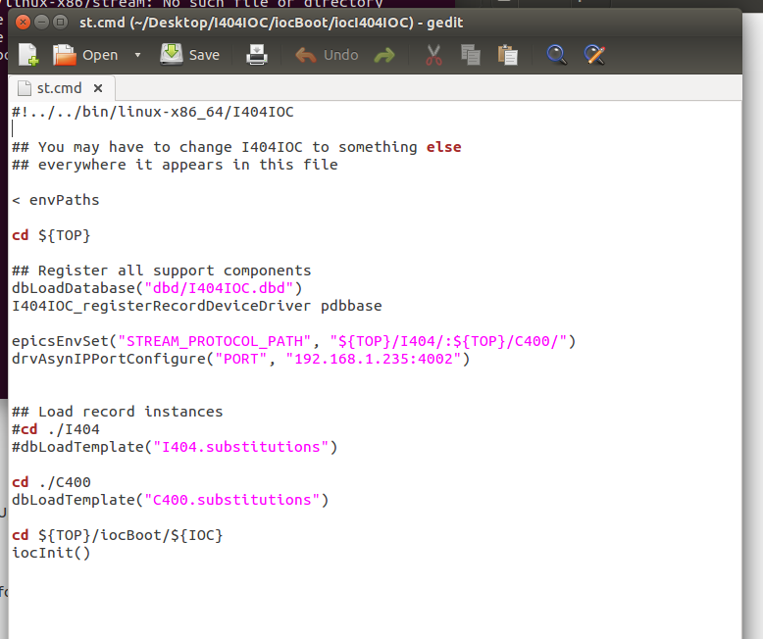

1. st.cmd file. Note that the I404.substitutions are suppressed by #. The : in epicsEnvSet means both places. The drvAsynIPPortConfigure line is important; the 4002 number means that port 2 on the MOXA is to be used.

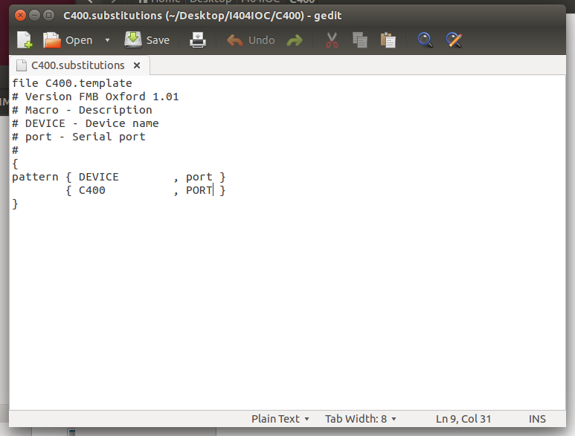

1. C400.substitutions. Note the case-sensitivity.

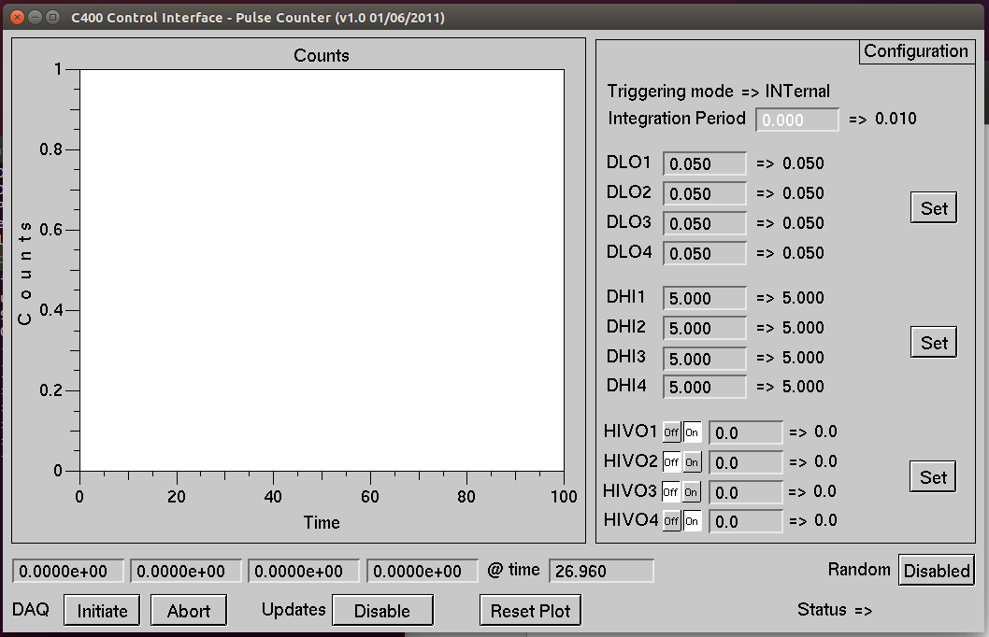

1. C400 GUI